Chapter 12, Solution 58.

The schematic is shown below. IPRINT is inserted in the neutral line to measure the current through the line. In the AC Sweep box, we select Total Ptss = 1, Start Freq. = 0.1592, and End Freq. = 0.1592. After simulation, the output file includes

FREQ IM(V_PRINT4) IP(V_PRINT4)

1.592 E–01 2.156 E+01 –8.997 E+01

i.e. I_{n} = 21.56∠–89.97° A
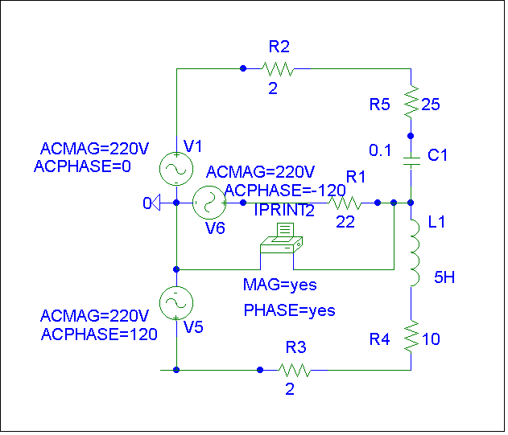
ACMAG=440V
ACMAG=440V
ACMAG=440V

